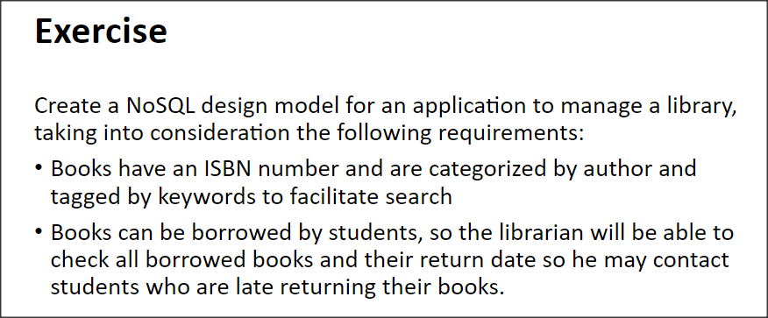

{

_id : objectId(),

isbn: '1234567',

author: 'author1',

tags: ['tag1', 'tag2', ...],

status: 'available / not available',

last_return_date: ,

last_borrow_date: ,

last_borrowedBy_studentName: 'student1',

last_borrowedBy_emailAddress: 'student1@mum.edu',

hists: [

{

borrow_date: ,

return_date: ,

student_name: 'student1',

student_emailAddress: 'student1@mum.edu'

},

{

borrow_date: ,

return_date: ,

student_name: 'student2',

student_emailAddress: 'student2@mum.edu'

},

{

borrow_date: ,

return_date: ,

student_name: 'student1',

student_emailAddress: 'student1@mum.edu'

}

]

}